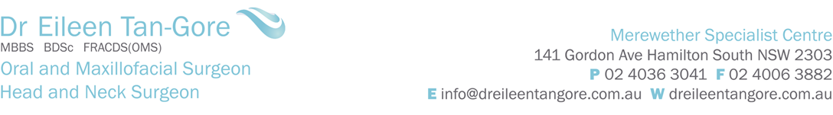

WISDOM TEETH
The procedure is performed under a general anaesthetic. It is day surgery and does not usually require an overnight stay in hospital.
A long-acting local anaesthetic is injected whilst you are asleep. This keeps you comfortable during and after the procedure.
Small incisions in your gum may be made to expose the base of the tooth.
The surgical removal of wisdom teeth may require removal of bone or sectioning of teeth with a surgical drill to facilitate complete removal of the tooth.
Resorbable sutures may be used to close any defects created by the removal of your tooth. These usually dissolve in 1-2 weeks.
You will receive a script for:
- Pain relief, to be taken at regular time intervals
- Chlorhexidine mouthwash, to be used after meals
Dr Tan-Gore does not routinely prescribe antibiotics for wisdom teeth extraction. You will be given a script for antibiotics, which is only to be filled if Dr Tan-Gore advises you to do so.
Most patients will require 2 weeks off work. It can take up to 4 weeks for swelling to completely resolve. You can discuss your work certificate requirements with Dr Tan-Gore.
Dr Tan-Gore will review you in her clinic 1-2 weeks after your surgery.

POST OPERATIVE INSTRUCTIONS
Pain and swelling during recovery from wisdom teeth surgery varies greatly between patients. It is important that you get plenty of rest, hydration and nutrition during the recovery period.

Day 0-7
Pain: Pain and swelling are common after removal of wisdom teeth. It is important to be comfortable during the healing period by:
- Taking your pain relief regularly – consider setting an alarm to remind you. It is important to take the prescribed pain relief regularly even if you feel that the pain is bearable. This prevents breakthrough pain which may require more analgesia to control. It is important that you are comfortable during the initial stages of your recovery.
- Using ice packs can help to decrease swelling – use a covered ice pack for 10 mins at a time, with a 10 min break in between. You may still be numb from the local anaesthetic, so please check the ice pack with your hand from time-to-time to make sure it is not too cold for you to tolerate.

Oral Care: If you are unable to open your mouth because of swelling, you must use the Chlorhexidine mouthwash after each meal. Gently rinse your mouth out after eating – swish the Chlorhexidine solution around and then spit it out. Do not vigorously gargle as this may dislodge the clot in the tooth socket that is required for healing. Once you can open your mouth, return to brushing your teeth regularly and stop using the Chlorhexidine mouthwash. You may find it easier to use a soft infant-sized toothbrush initially.

Diet: It is important to keep up your hydration and nutrition during your recovery. Dr Tan-Gore recommends that you start with a liquid diet initially. Consider protein shakes as a way to increase calorie-intake on a liquid diet. Progress to a soft diet as you feel able to. Drink plenty of fluids but avoid fizzy or sugary drinks.

Exercise: Gentle exercise such as walking and stretching is ok. Impact exercise such as jogging and working out at the gym should be avoided for 1-2 weeks, depending on your recovery. Limit talking in the initial stages as this can worsen the inflammation and swelling initially.

Day 8-14
You should start to feel better 1 week after your operation. Post-operative swelling generally gets worse at 3-5 days before slowly improving.
You may still require regular pain relief. However, if you feel better, you could consider skipping doses. Continue with the night dose of pain relief to aid with sleeping.
You should be able to open your mouth wider and should be slowly returning to your usual oral care routine. If you still feel that you need to rinse your mouth gently after meals, warm salty water is adequate (dissolve half teaspoon of salt in half cup of warm water).
You can slowly progress your diet as you feel comfortable. If progressing your diet causes discomfort or pain, give yourself a rest on a softer diet and try again in a few days.

Day 15-28
You should be progressing well by this stage. Some patients will have returned to work and to their usual activities. However, some patients may still have some pain and swelling up to 4 weeks after their surgery. Gradually progress to your preoperatively levels of activity if you feel up to it

